

**Title: Landing page for product**

**Course: UI/UX Design Fundamentals**

**Institution: Christ University**

**Date of Submission: 26/09/2025**

**Submitted By:**

**Krish D R : 2460480 :** [**krish.dr@btech.christuniversity.in**](mailto:krish.dr@btech.christuniversity.in)

**Likith N A : 2460825 : likith.na@btech.christuniversity.in**

**John Jomi: 2460381 :**

**2. Abstract**

This document abstracts the design of a premium landing page for the "Aura Smart Backpack." Inspired by Apple's minimalist aesthetic, the webpage uses a clean, narrative-driven layout to showcase the product's intelligent features, such as GPS tracking and biometric security. Built with HTML, CSS, JavaScript, and Bootstrap, the fully responsive and interactive site is designed to engage modern travelers and drive conversions through a compelling user experience.

**3. Objectives**

* **Drive Conversions:** To persuade visitors to purchase the product through compelling visuals, persuasive copy, and prominent "Buy Now" call-to-action buttons.
* **Showcase Key Features:** To clearly inform potential customers about the backpack's unique functionalities, such as GPS tracking, biometric security, and the integrated power hub.
* **Establish a Premium Brand Identity:** To create a high-end brand perception by emulating Apple's minimalist, clean, and modern design aesthetic.
* **Enhance User Engagement:** To captivate the user with an interactive experience using a narrative-driven layout, smooth scroll animations, and a dynamic testimonial carousel.

**4. Scope of the Project**

* Develop a single, static product landing page.
* Focus on front-end development only, with no backend integration.
* Exclude functional e-commerce, payment processing, or a live shopping cart.
* Implement predefined sections: Hero, Features, Testimonials, and CTA.
* Ensure a fully responsive design for all desktop and mobile devices.

**5. Tools & Technologies Used**

| **Tool/Technology** | **Purpose** |
| --- | --- |
| HTML5 | Content structure |
| CSS3  JavaScript | Styling and layout  Interactive |
| VS Code | Code editing |
| Chrome DevTools | Testing & debugging |
| Placedog.net / Placekitten.com | Placeholder images |

**6. HTML Structure Overview**

* **Header**: Site title and navigation links.
* **Features Section**: Grid of cards for each feature with image and description
* **Modals**: Hidden sections revealed on click, showing detailed info.
* **Buy Button**: Allows users will taken to payment page if backend was appllied

**7. CSS Styling Strategy**

* **External Stylesheet** for maintainability.
* **Grid Layout & Flexbox** for responsive pet card arrangement.
* **Box Shadows & Rounded Corners** for card and modal aesthetics.
* **Hover Effects** on buttons and download link.
* **Modal Styling** using :target selector for pure CSS popups.
* **Color Theme**: Soft pastel shades (#ffe4e1, #ffb6c1, #fff8f0) to create a welcoming feel.

**8. JavaScript Overview**

* Makes websites **interactive**.
* Runs directly **in the browser** (client-side).
* Changes **HTML and CSS** content dynamically.
* Handles user **events** like clicks and scrolls.
* Powers servers and backends via **Node.js**.
* Used with popular frameworks like **React** and **Vue**.

**8. Key Features**

| **Feature** | **Description** |
| --- | --- |
| Responsive Grid | Adjusts features cards for different screen sizes. |
| CSS-Only Modals | Displays pet details without reloading the page. |
| Themed UI | Soft, friendly color palette. |
| Downloadable PDF | Direct link to application form. |
|  |  |

**9. Challenges Faced & Solutions**

| **Challenge** | **Solution** |
| --- | --- |
| Maintaining image aspect ratios | Used fixed-width responsive image containers with border-radius. |
| Aligning cards evenly | Used Flexbox with gap property. |
| Pure CSS modals  Ensuring animations were smooth and performant. | Implemented :target selector with hidden divs and close buttons.  Used efficient **CSS transitions** for animations, |

**10. Outcome**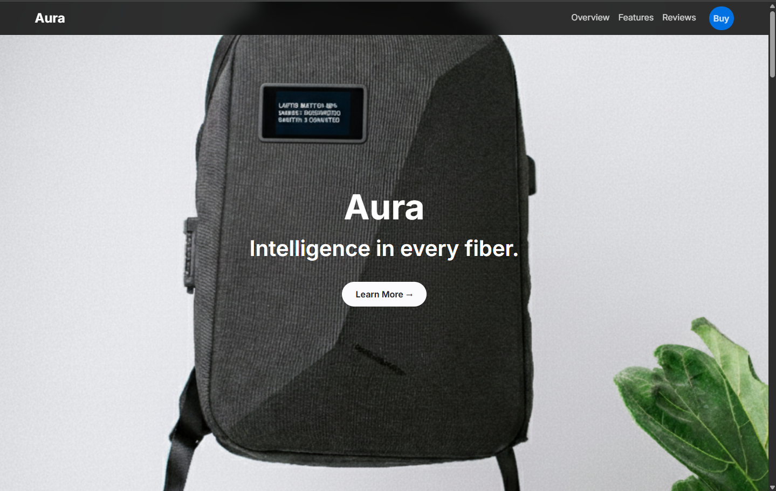

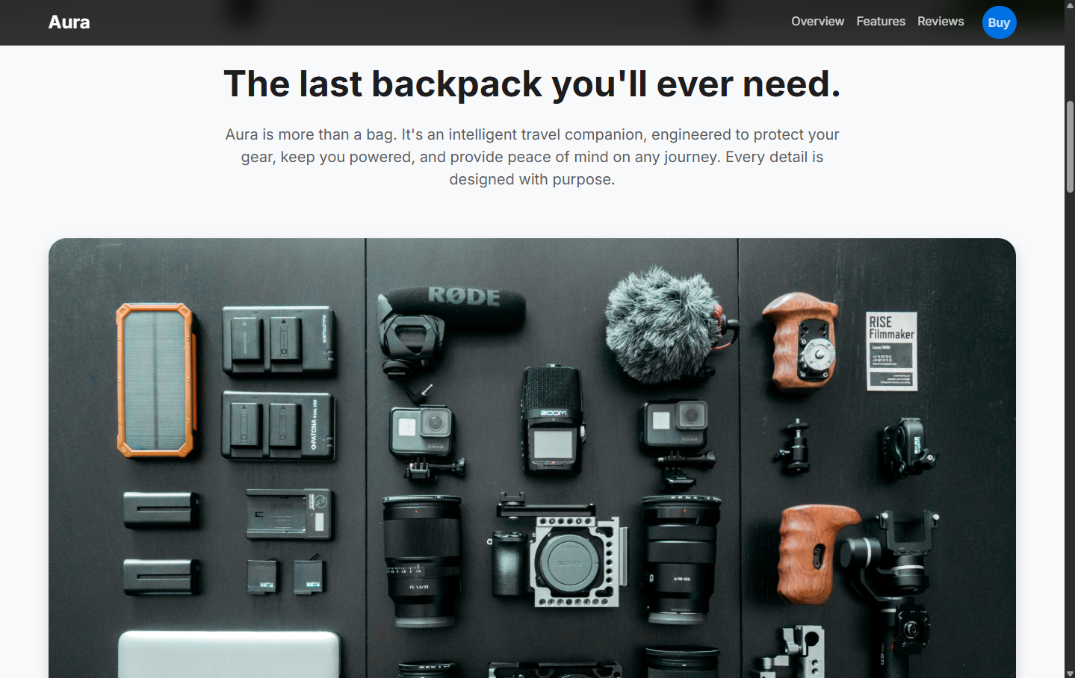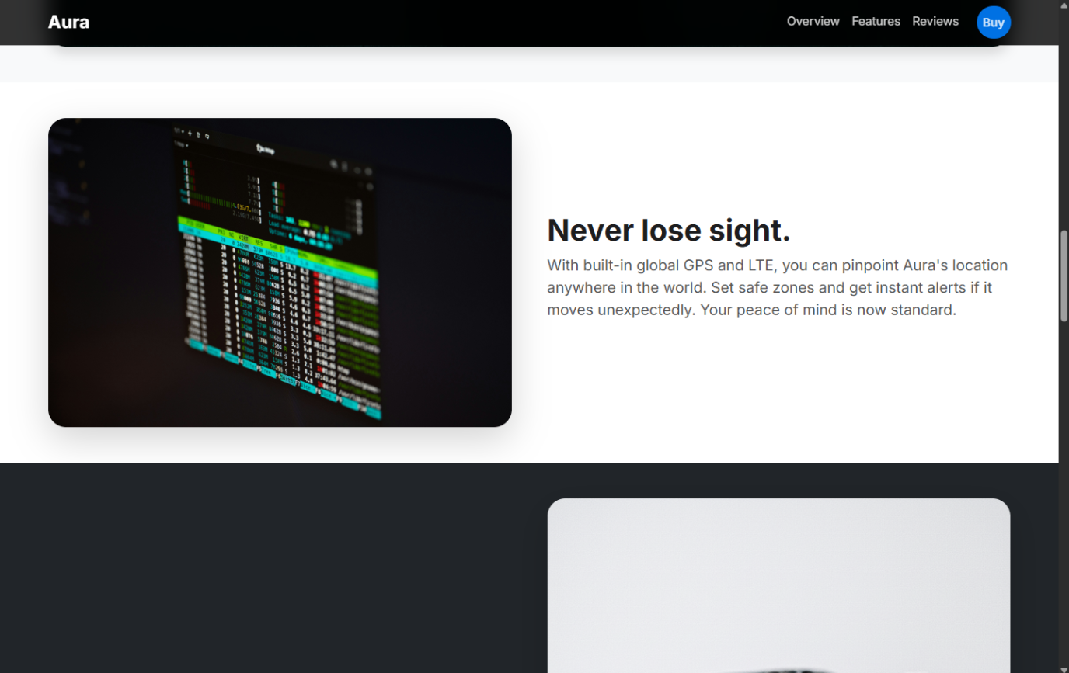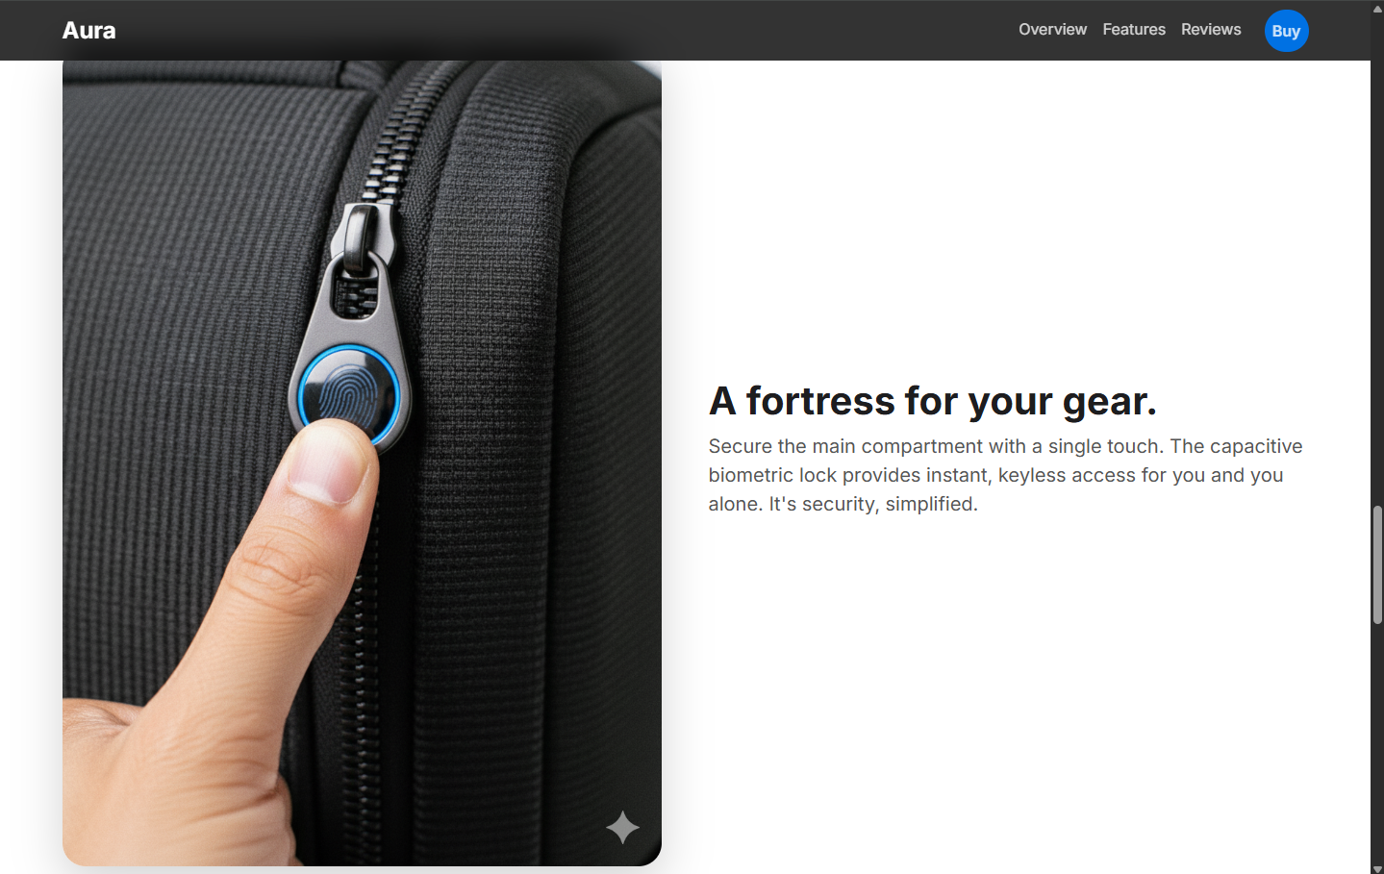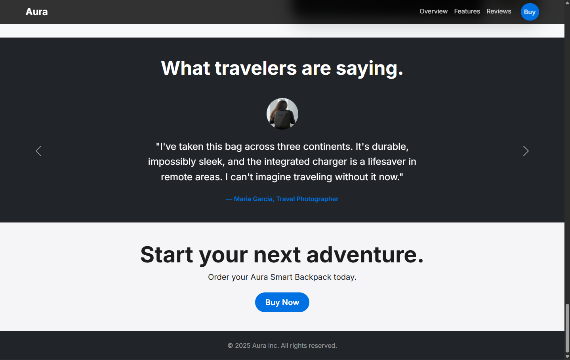

**11. Future Enhancements**

* Integrate a **search function**
* Implement backend database for real applications.
* Add **light/dark theme toggler**.
* Include animations for modal transitions.

### ****12. Sample Code****

**HTML Snippet (Pet Card)**

!DOCTYPE html>

<html lang="en">

<head>

    <meta charset="UTF-8">

    <meta name="viewport" content="width=device-width, initial-scale=1.0">

    <title>Aura Smart Backpack - Journey Redefined</title>

    <link href="https://cdn.jsdelivr.net/npm/bootstrap@5.3.3/dist/css/bootstrap.min.css" rel="stylesheet">

    <link rel="stylesheet" href="https://cdn.jsdelivr.net/npm/bootstrap-icons@1.11.3/font/bootstrap-icons.min.css">

    <link rel="stylesheet" href="style.css">

    <link rel="preconnect" href="https://fonts.googleapis.com">

    <link rel="preconnect" href="https://fonts.gstatic.com" crossorigin>

    <link href="https://fonts.googleapis.com/css2?family=Inter:wght@400;600;700&display=swap" rel="stylesheet">

</head>

<body>

    <nav class="navbar navbar-expand-lg navbar-dark fixed-top">

        <div class="container">

            <a class="navbar-brand" href="#">Aura</a>

            <button class="navbar-toggler" type="button" data-bs-toggle="collapse" data-bs-target="#navbarNav" aria-controls="navbarNav" aria-expanded="false" aria-label="Toggle navigation">

                <span class="navbar-toggler-icon"></span>

            </button>

            <div class="collapse navbar-collapse" id="navbarNav">

                <ul class="navbar-nav ms-auto">

                    <li class="nav-item"><a class="nav-link" href="#hero">Overview</a></li>

                    <li class="nav-item"><a class="nav-link" href="#features">Features</a></li>

                    <li class="nav-item"><a class="nav-link" href="#testimonials">Reviews</a></li>

                    <li class="nav-item"><a class="nav-link btn btn-primary-custom ms-lg-3" href="#">Buy</a></li>

                </ul>

            </div>

        </div>

    </nav>

**CSS Snippet (Card Styling)**

:root {

    --primary-color: #0071e3;

    --dark-color: #1d1d1f;

    --near-black: #111;

    --light-color: #f5f5f7;

    --text-color-dark: #1d1d1f;

    --text-color-light: #fbfbfd;

}

body {

    font-family: 'Inter', -apple-system, BlinkMacSystemFont, "Segoe UI", Roboto, "Helvetica Neue", Arial, sans-serif;

    background-color: #fff;

    color: var(--text-color-dark);

    scroll-behavior: smooth;

}

h1, h2, h3, h4, h5, h6, .display-1, .display-2, .display-3, .display-4, .display-5, .display-6 {

    font-weight: 700;

}

**JavaScript Snippet**

$(document).ready(function(){

    $('.navbar-nav a').on('click', function(event) {

        if (this.hash !== "") {

            // Prevent default anchor click behavior

            event.preventDefault();

            var hash = this.hash;

            // Animate scroll

            $('html, body').animate({

                scrollTop: $(hash).offset().top

            }, 800, function(){

                // Add hash to URL after scroll

                window.location.hash = hash;

            });

        }

    });